QUESTIONS
1. WHERE Clause
Q1. Filter all transactions that occurred in the year 2023. Expected output: All columns

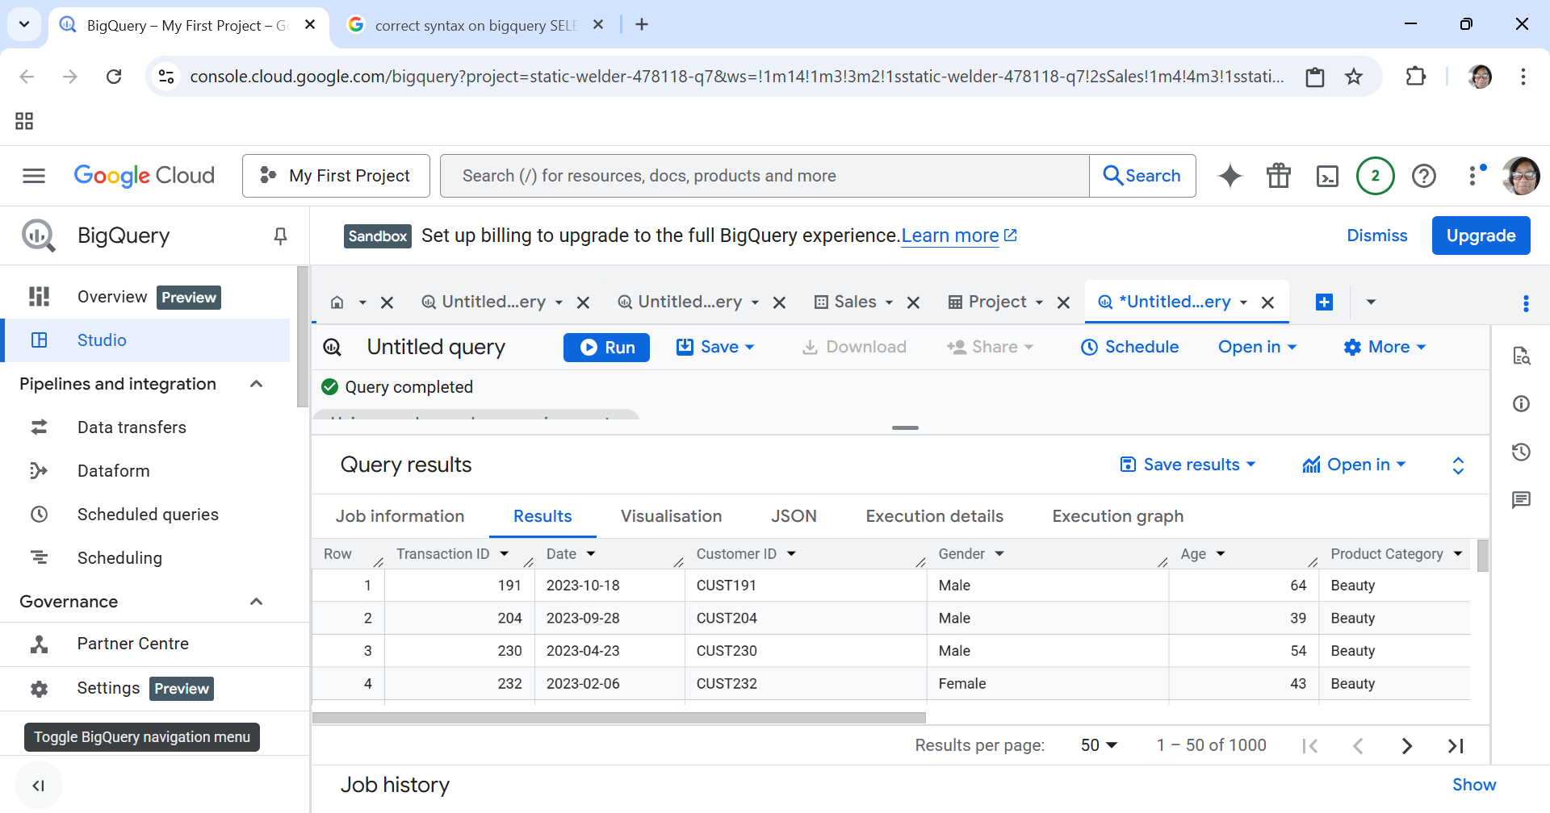

2. Filtering + Conditions
Q2. Display all transactions where the Total Amount is more than the average Total Amount of the entire dataset. Expected output: All columns
First calculated the average:
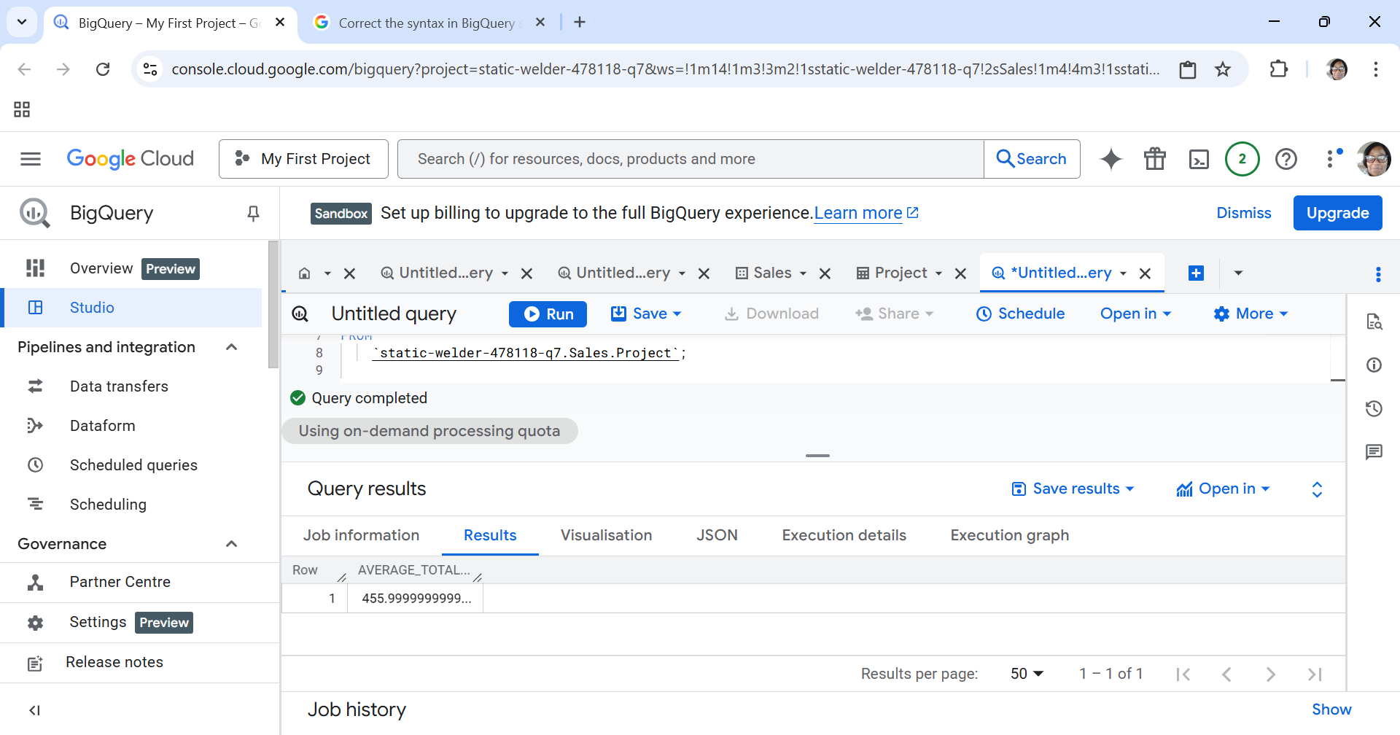

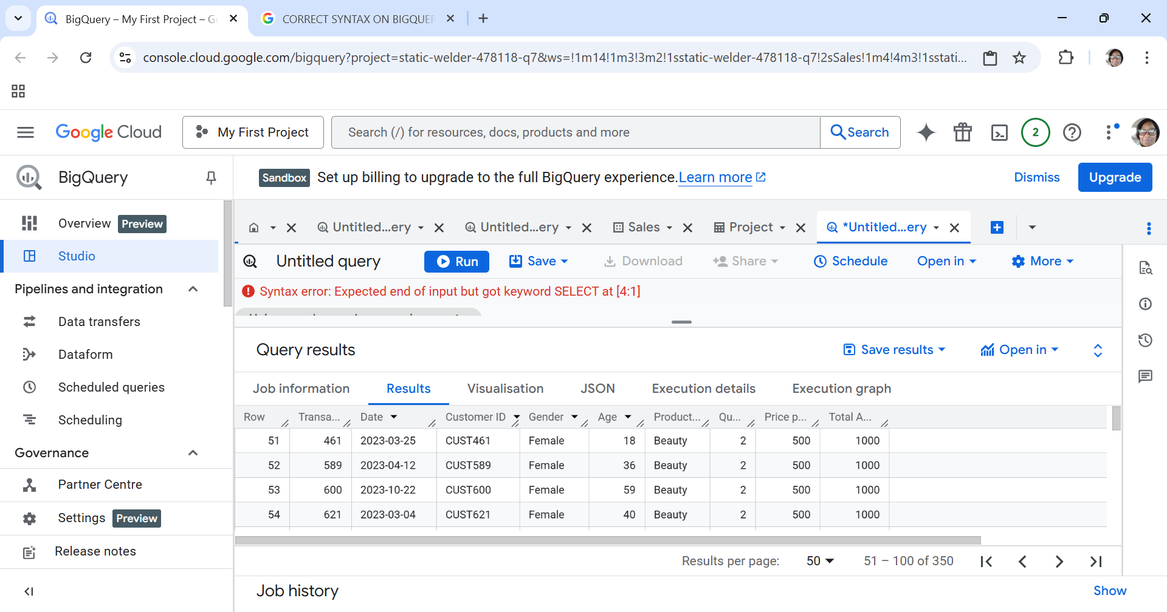

3. Aggregate Functions
Q3. Calculate the total revenue (sum of Total Amount). Expected output: Total_Revenue
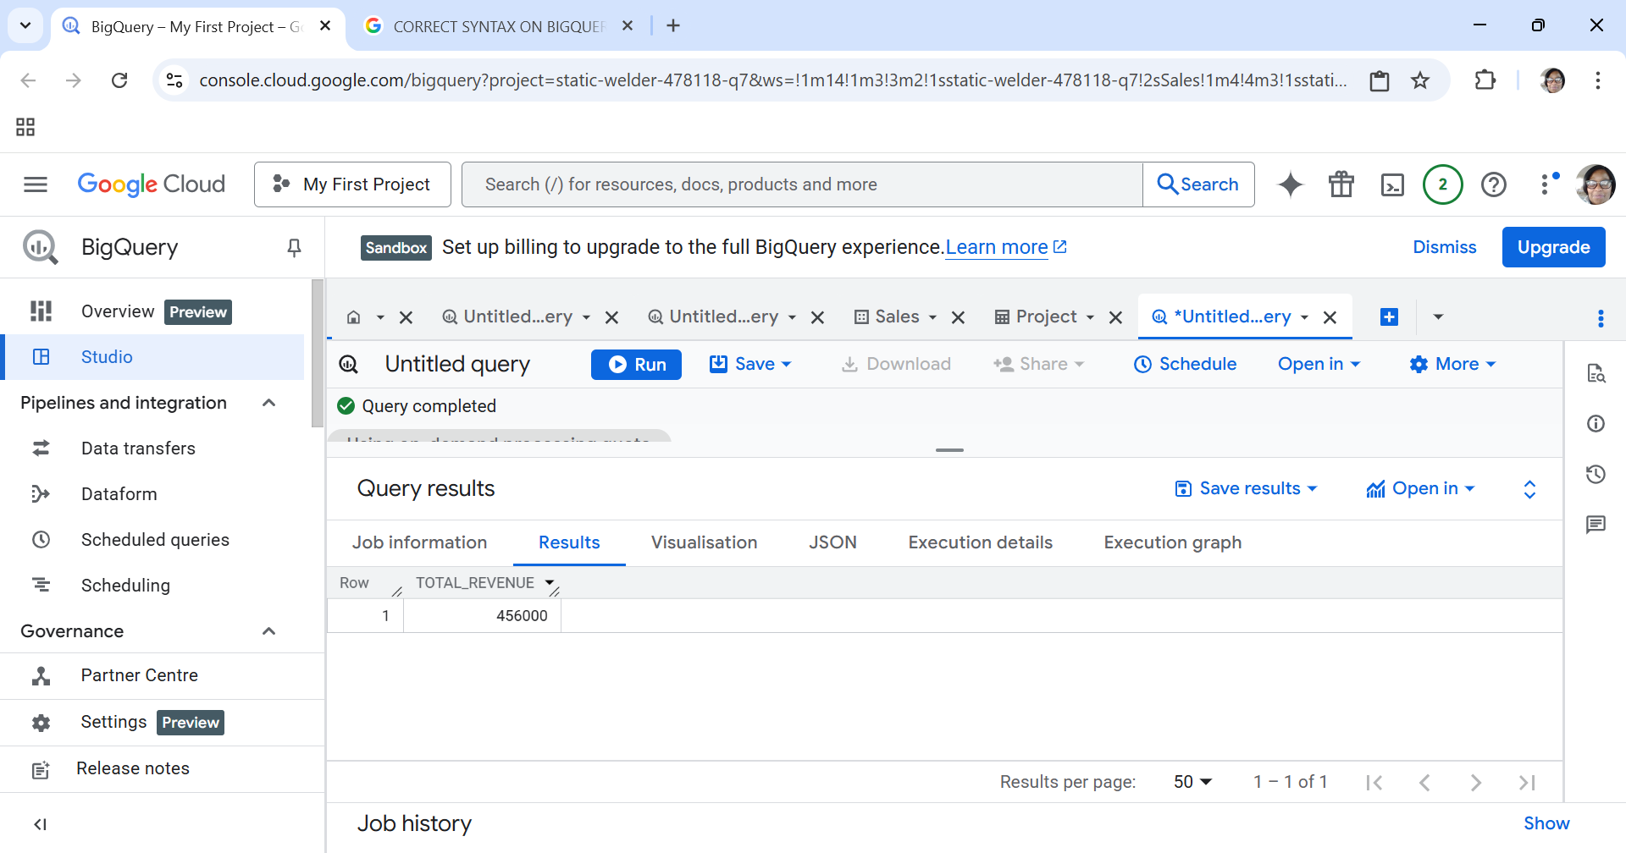

4. DISTINCT
Q4. Display all distinct Product Categories in the dataset. Expected output: Product_Category

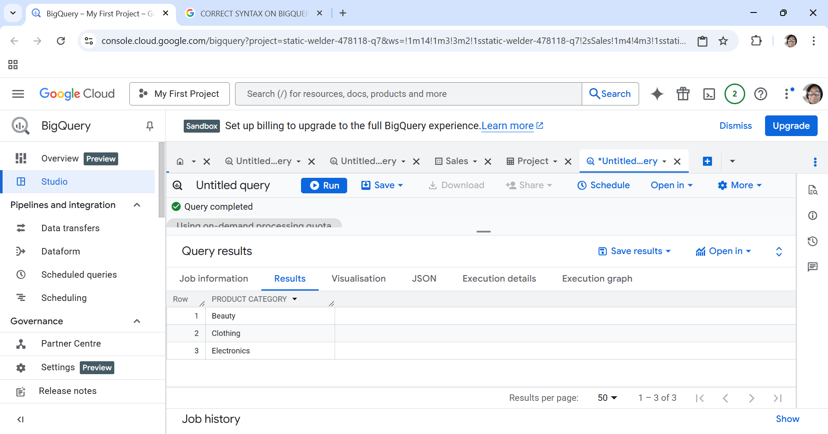

5. GROUP BY
Q5. For each Product Category, calculate the total quantity sold. Expected output: Product_Category, Total_Quantity

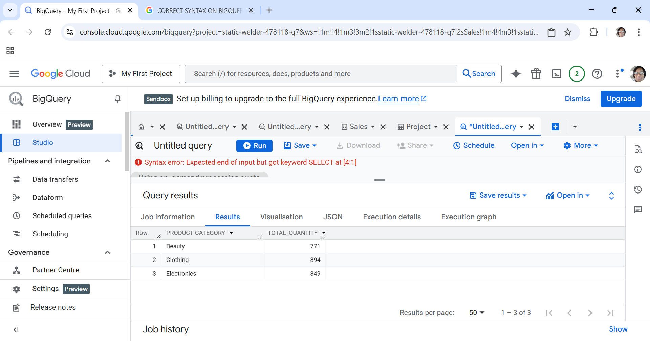

6. CASE Statement
Q6. Create a column called Age_Group that classifies customers as ‘Youth’ (<30), ‘Adult’ (30–59), and ‘Senior’ (60+). Expected output: Customer_ID, Age, Age_Group
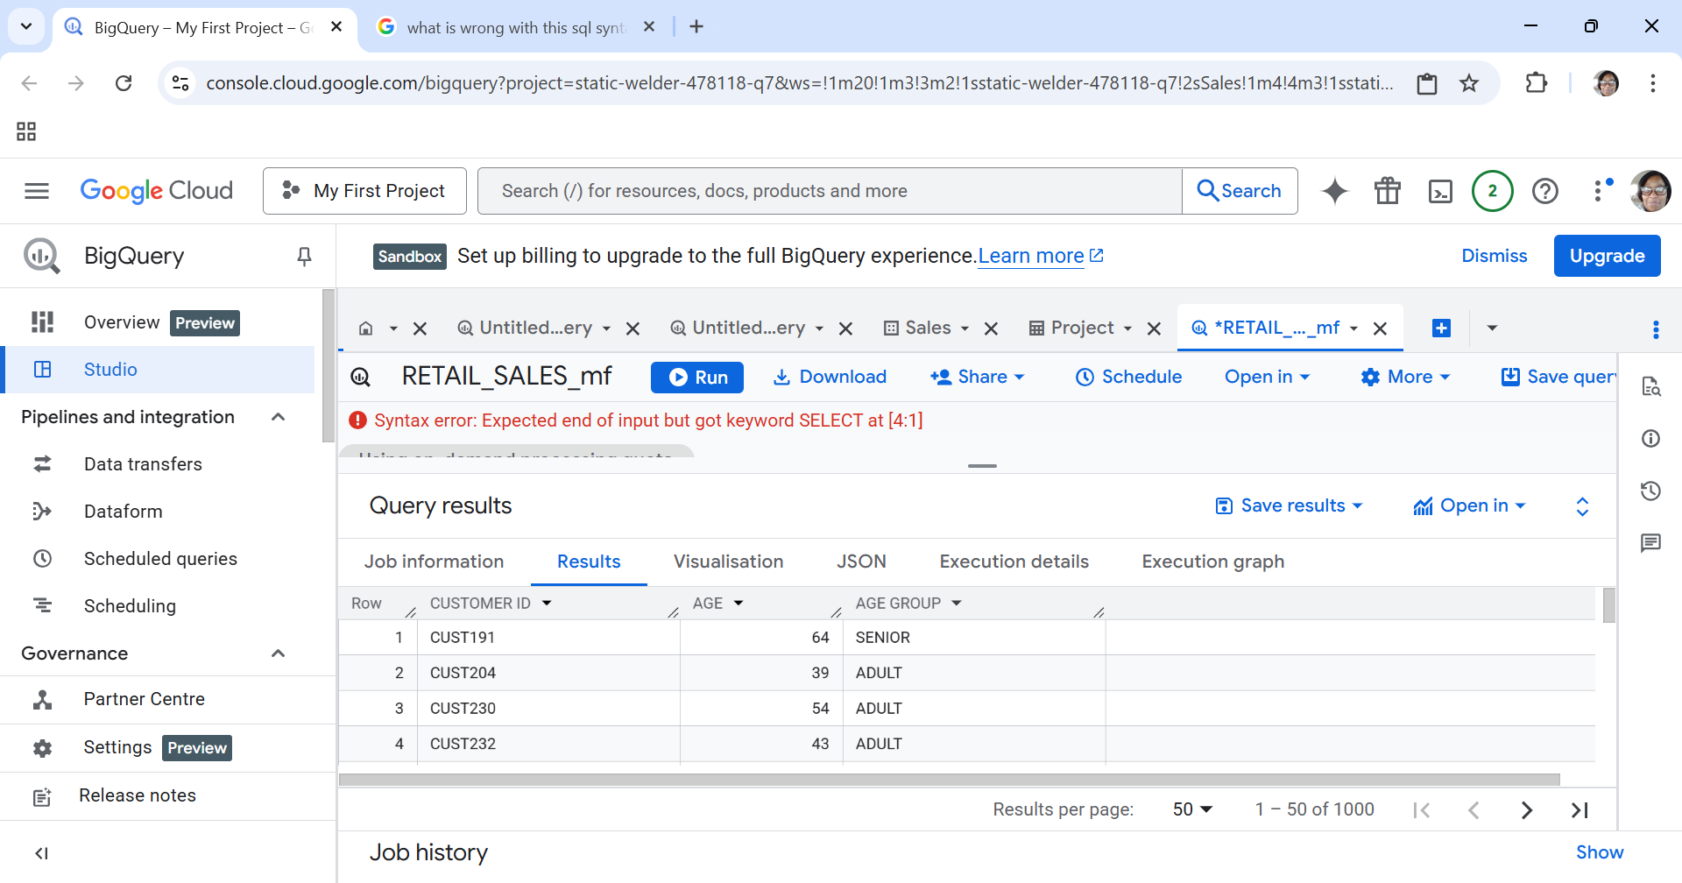

7. Conditional Aggregation

Q7. For each Gender, count how many high-value transactions occurred (where Total Amount > 500). Expected output: Gender, High_Value_Transactions

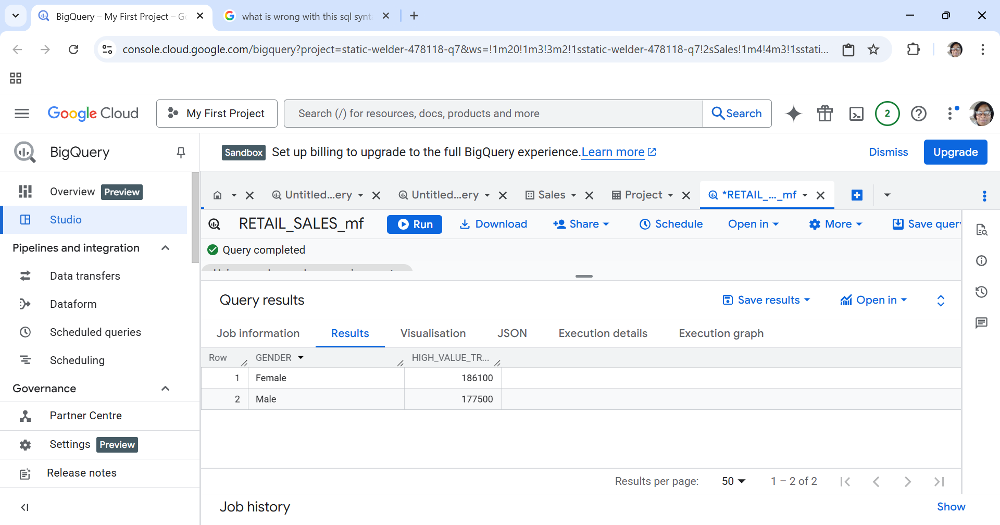

8. HAVING Clause
Q8. For each Product Category, show only those categories where the total revenue exceeds 5,000. Expected output: Product_Category, Total_Revenue
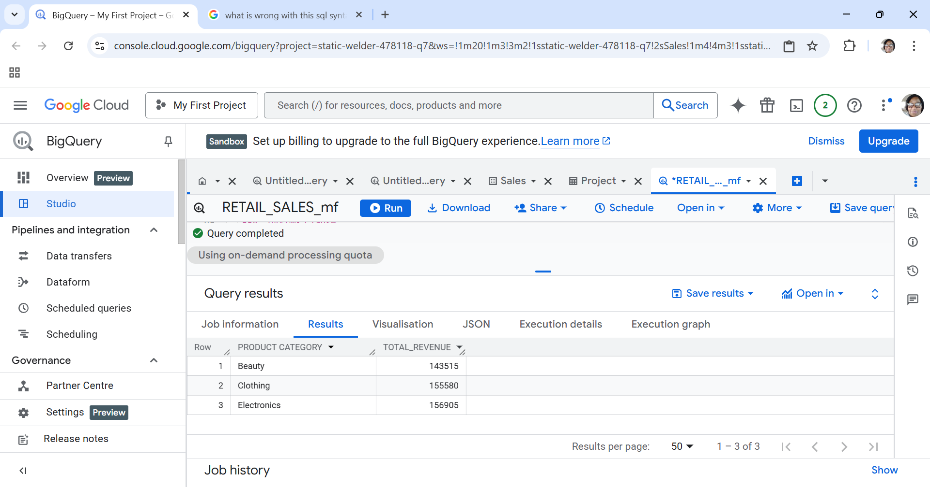
9. Calculated Fields
Q9. Display a new column called Unit_Cost_Category that labels a transaction as: – 'Cheap' if Price per Unit < 50 – 'Moderate' if Price per Unit between 50 and 200 – 'Expensive' if Price per Unit > 200 Expected output: Transaction_ID, Price_per_Unit, Unit_Cost_Category
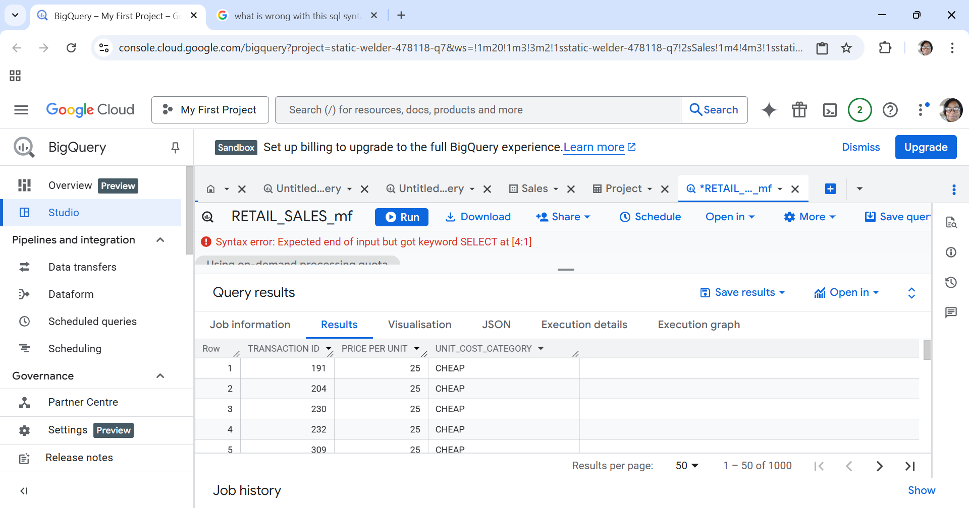

10. Combining WHERE + CASE
Q10. Display all transactions from customers aged 40 or older and add a column Spending_Level showing ‘High’ if Total Amount > 1000, otherwise ‘Low’. Expected output: Customer_ID, Age, Total_Amount, Spending_Level
